Machine Learning

Perceptron

Support Vector Machines

Dimensionality

We can loosely describe the implications of large dimensions by considering a region S = [0 s]^D contained within a unit hypercube V = [0 1]^D. The model will be

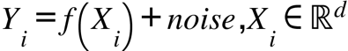

and

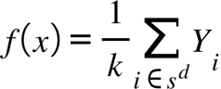

the estimator. The probability of N samples inside S is

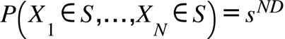.

Since s<1, the probability for even a few samples is essentially zero as D becomes large. If we instead use a large number of samples N and ask only that k of them lie within the sub-region, then the number of samples is binomial with probabilility s^D. The expected value of this number is

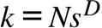

From this we can determine the size of the subcube, or fractional volume of V, required to on average ensure k samples are observed. This quantity is plotted in Figure () and shows that even for a large sample size, achieving 100 points in the region requires s to approach 95% of the total volume. In this case the concept of locality disappears and nearest neighbor methods fail. The variance of combining k samples is proportional 1/k. With k described by () the variance approaches infinity. A large neighborhood is required to achieve more points and reduce the vairance. In large dimensions this neighborhood is also very large, thus combining dissimilar samples increases the bias of the estimate. However, the large neighborhood accounts for a very small percent of total samples as shown in Figure (). At s=100, 100 samples requires 95.5% of the total volume, while accounting for only 1% of total samples (s^D)!
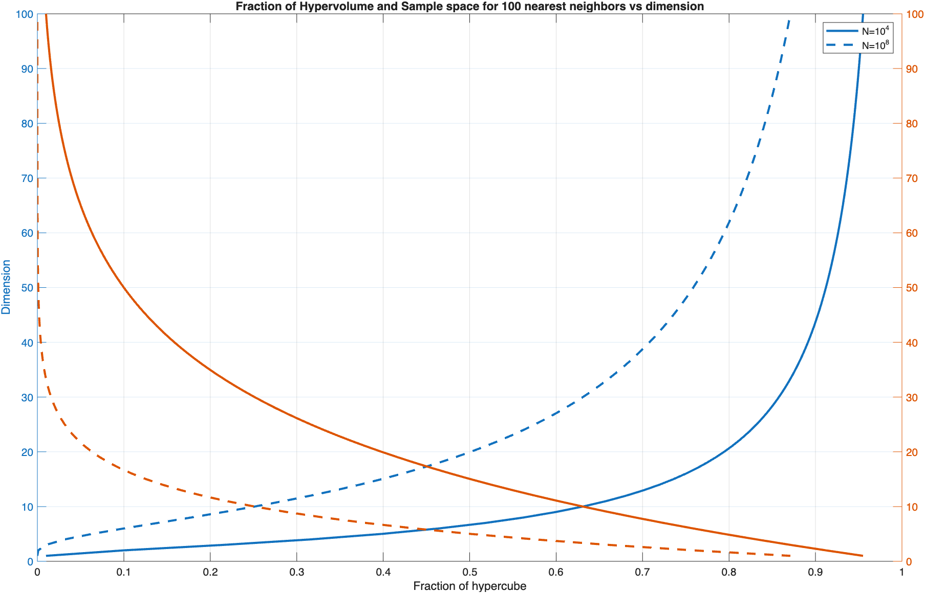

Under some fairly general conditions the bias can be shown (using Taylor series) proportional to the second derivative (a constant function has low error) times the square of the interval. The variance is inverse to the number of samples k. Since MSE is bias^2 + variance,

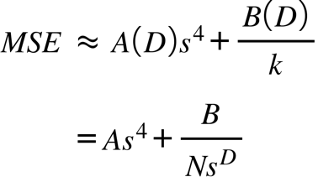

Eq is indicative of a bias-variance trade off. Estimating with a small s combines closely related samples resulting in low bias. Increasing s to increase the number of samples, and hence lower the variance, is exponentially stymied by D. Increasing N is to no avial as also swamped for large D. A plot of () is provided in Figure () and illustrates the complementary increasing bias and decreasing variance as a function of the estimation interval. The optimimum interval size minimizes the MSE.

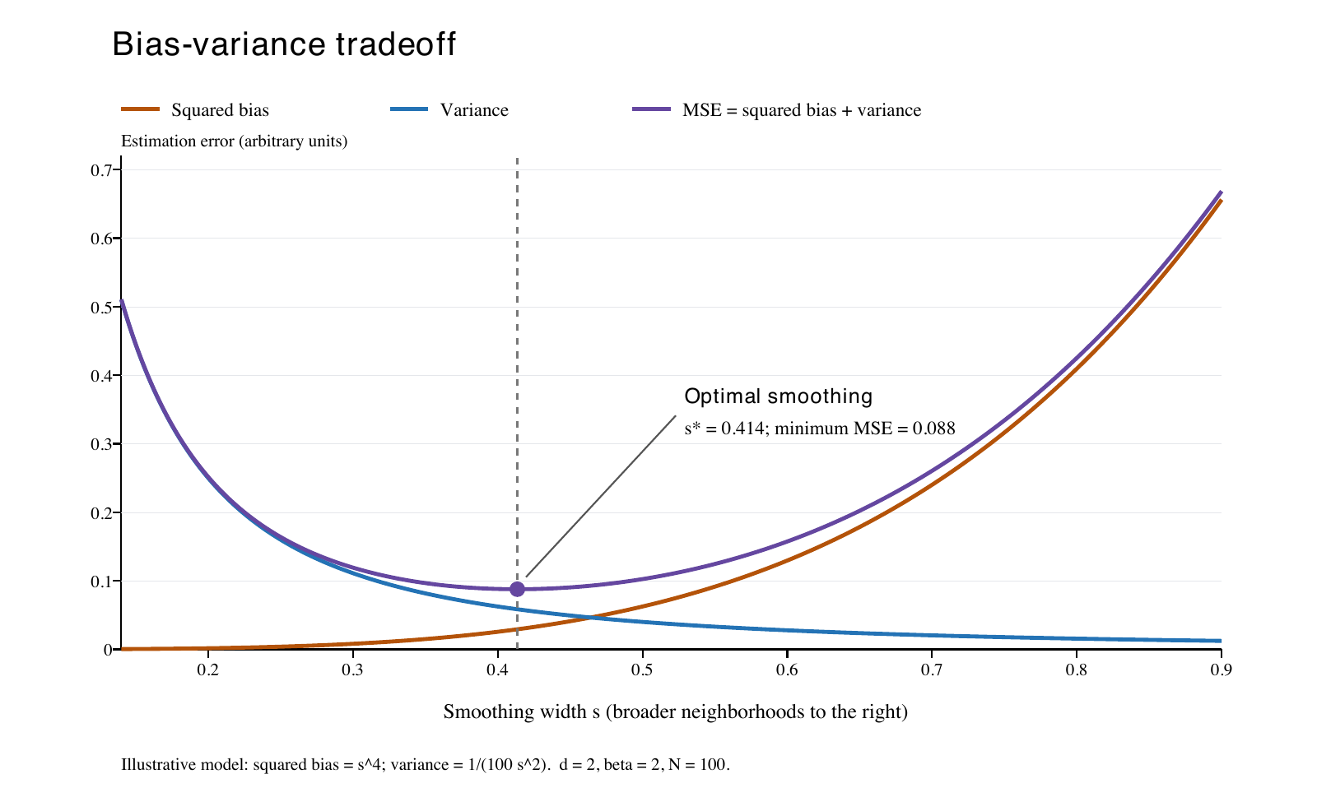

Another issue is extra dimensions can obscure similarity. When comparing iid points x and x' using a distance measure, suppose n coordinates are the equal or noise only with variance sigma2. The distance is

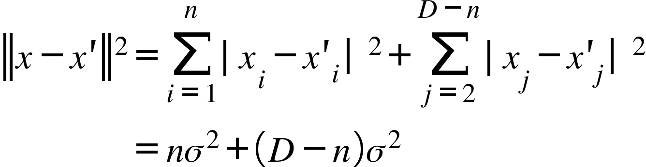

With D>>n, the latter terms dominate the distance measure and nearest neighbor selection becomes driven by noise rather than structure.

These effects are known as "the curse of dimensionality," attributed to R.E. Bellman in 1961 during work on dynamica programming. The antidote to COD is structure.

“Structure” means that the function or data follows reusable patterns, so we don’t have to estimate a separate answer for every possible combination of inputs.
Without structure, a function of \(d\) variables could behave differently in every small region. If we divide each coordinate into 10 intervals, there are \(10^d\) regions to learn about.
Structure ties those regions together: learning something in one place tells us something elsewhere.
1. Linearity: one global rule replaces many local estimates.
Suppose:
\[ Y=w_1X_1+\cdots+w_dX_d+\epsilon \]
Even if \(d=100\), the mean response is determined by only 100 coefficients.
An observation informs those shared coefficients, which then affect predictions throughout the space. We don’t need samples near every possible input.
The assumption is restrictive: if the true relationship is strongly nonlinear, a linear model can have substantial bias.
2. Sparsity: only a few variables matter.
Suppose the input has 100 coordinates, but:
\[ Y=f(X_3,X_{17})+\epsilon \]
The prediction problem is effectively two-dimensional if we know which coordinates matter.
The other 98 coordinates need not enter the model or its distance calculation. If we don’t know the relevant variables, identifying them requires additional data and assumptions—but we still may avoid estimating an arbitrary function of all 100 variables.
3. Additivity: many variables matter, but not through every interaction.
An additive model assumes:
\[ f(x_1,\ldots,x_d)=f_1(x_1)+\cdots+f_d(x_d) \]
Each \(f_j\) can be nonlinear. But we estimate \(d\) one-dimensional curves rather than one unrestricted \(d\)-dimensional surface.
For example:
\[ \text{heating cost} =f_1(\text{floor area})+f_2(\text{outside temperature}) \]
This saves complexity by excluding interactions. If the effect of temperature changes dramatically with floor area, that simple additive form may be inadequate.
4. Low intrinsic dimension: the data occupies only part of the ambient space.
A point may have 100 coordinates but be generated by two underlying variables:
\[ x=g(u,v)\in\mathbb R^{100} \]
The samples lie on a two-dimensional surface inside the 100-dimensional space.
We need to learn where the data actually occurs—not throughout every possible combination of 100 coordinates. This helps when the underlying surface and target function are sufficiently regular.
Notice the distinction:
- Sparsity: a few original coordinates matter.
- Low intrinsic dimension: a few underlying variables control many coordinates.
5. Low rank: many outputs share a small set of patterns.
This is exactly our toy model:
\[ A=WE \]
An unrestricted \(A\) has \(V^2\) independently adjustable scores. With embedding dimension \(d\), the factorization uses \(2Vd\) parameters and enforces:
\[ \operatorname{rank}(A)\leq d \]
Each input’s score vector is a combination of the same \(d\) output patterns:
\[ A[:,x]=\sum_{j=1}^{d}E_{j,x}W[:,j] \]
Learning \(W\) from one training pair can therefore affect predictions for other inputs. That sharing is how information transfers between examples. Fewer parameters alone do not guarantee good estimation; the shared structure must fit the data reasonably well.
6. Composition: complicated behavior is built from reusable simpler operations.
A function might have the form:
\[ f(x)=g\bigl(f_1(x),f_2(x),f_3(x)\bigr) \]
If those component functions are simpler than an unrestricted \(f\), learning their composition can be more efficient.
Neural networks build in this possibility. In transformers, the same attention and feedforward parameters are reused across positions and examples, rather than learning a separate predictor for every sentence.
These assumptions connect directly to the bias–variance tradeoff:
- Too little structure: high flexibility, but potentially enormous data requirements.
- Useful structure: shares information and improves estimation.
- Incorrect or excessive structure: forces the model toward systematically wrong answers, increasing bias.
The relevant question is therefore not simply “How many dimensions?” It is “How many independent relationships must the model learn, and which relationships can share a common rule?”

Discriminant analysis

Hidden Markov Models

Non-Parametric Estimation

Relying on data with very few additional assumptions instead of fixed model with a small number of unknown parameters.

Nearest Neighbor Estimation

K-Means Estimation

Neural Networks

Unsupervised Learning

Deep Learning Models

A simple LLM

Large language models (LLMs) generate text sequentially by predicting a probability distribution over the next token given the preceding context, then selecting a token from that distribution. The forward pass computes a score, or logit, for each candidate token in the vocabulary. An activation function converts these scores into probabilities. During training, a loss function measures how much probability the model assigns to the observed next token. Backpropagation computes gradients of this loss, and an optimizer updates the trainable parameters, including token embeddings and network weights. Each training example is an input–target pair (x,y), where x contains the context token ID and y identifies the observed next token. Tokens belong to a vocabulary of size V and a training sequence contains T tokens
.
The output model is a design choice. For the purposes of this discussion we use a linear model because it is simple enough to understand, mathematically tractable, while still illustrating useful concepts. As an example, consider a vocabulary {cat sat slept}. We need a function which provides a score for every combination of input/ouput. A matrix
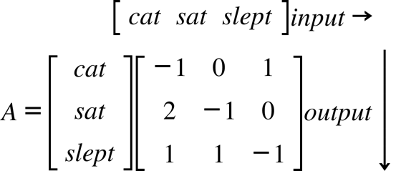

with ijth entry representing the score for predicting the ith token given jth token,
would be suitable. The score for each for each input/outptut pair would then be 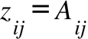. Given input 'cat', the output score 'cat' is not likely hence z = -1, the output 'sat' is very likely indicated by z=2, and slept (z=1) is possible but less likely.

The scores for input 'cat' must then be converted by an activation function to probability, say p(cat|cat)=0.01, p(sat|cat),=0.8 p(slept|cat) =0.19. In this case each token has its own column and the pediction score for cat is its column. Such a table would require V^2 entries and V is typically very large.

In a factorization model, each token is abstracted to a short feature vector with dimension K<<V. The columns of the K x V embedding matrix E consist of features for each token in V. To complete the feature to score mapping, E is multiplied by a shared V x K weight matrix W which generates a score in the same way for each token, rather than for each direct input/output as in A. This results in a compact representation requiring only 2VK values rather than V^2. The "new" A has rank K and must rely on reusable structure rather than exhaustive enumeration to generate scores.

In this simple linear model, the score

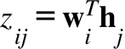

represents how strongly the embedding of input token j supports output candidate i.The goal of training is to learn wi and hj for all ij. Below we sketch out the elements of the model using simple functions for illustration of the concepts. Briefly, the steps are: forward input-output mapping, probability generation, backwards sensitivity estimation, optimization of loss, and then weight and embedding update.

A simple activation function, 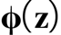, is the softmax operation which converts the logit into probability via

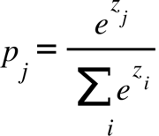

Here pj is the probability assigned to candidate token j given the previous token in the sequence. It represents the conditional probability

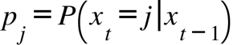

The training data contains the correct token sequence which is represented by a unit norm vector y. We will use one hot target indexing where

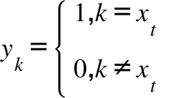

The loss function is the cross-entropy

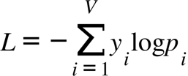.

which reduces to a single term for one hot weighting. The loss function connects the model's input to the desired output supplied by the training data. It is the performance grade furnished by the trainer.

Backward propagation reverses the processing chain to discover the sensitivity of an output to an input measured through the loss function. An optimization procedure uses this information to update and improve E and W. Gradient descent is a good place to start. The derivatives are with respect to E and W and are computed using the using the chain rule ( section OT)

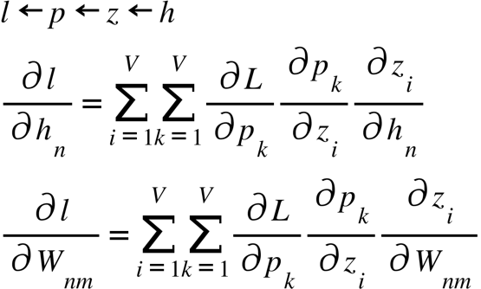

Here hn = E(n,xt), e.g the nth element of the feature corresponding to the token index x at sequence index t. The derivative wrt to the outer loss function is

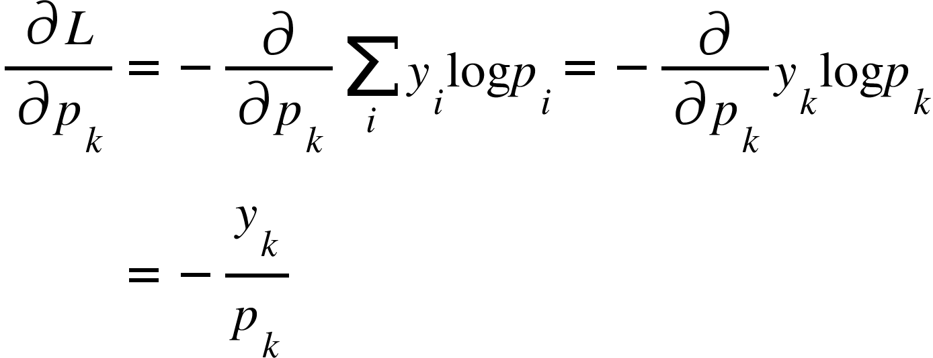

The middle term in () represents how the probability of token k changes when we change the score for token i. With S=sum(exp(zj)) and using the quotient rule for functions (f/g)'=(f'g-fg')/fg with g=S) there are two cases: i=k, and i~=k.

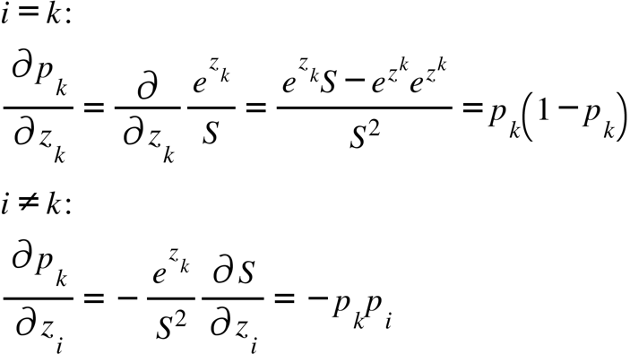

These can be combined to yield

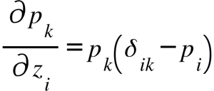

Given that

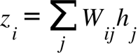

the inner function derivative is

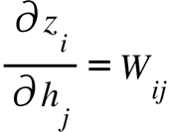

Putting it all together,

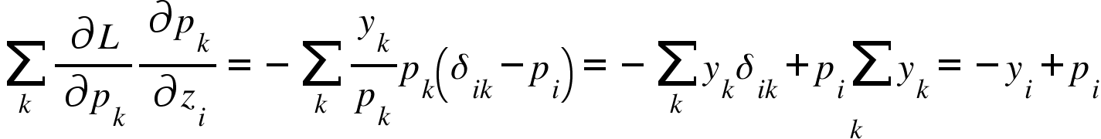

because y sums to one. Finally,

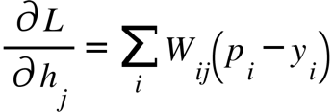

Amazingly, the embedding gradient is simply

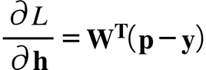

The computation wrt W is

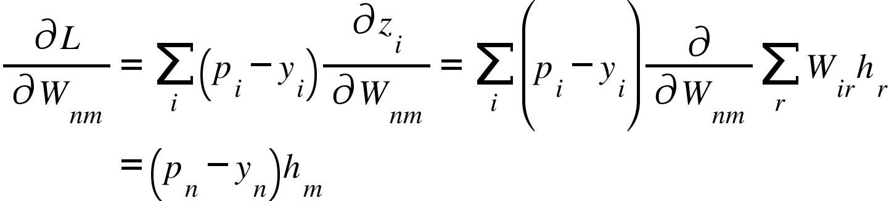

where we have used the fact that the expression is nonzero only for i=n and r = m. Collecting the entries into a matrix gradient yields

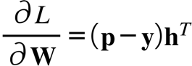

The descent rule for optimizing E and W is

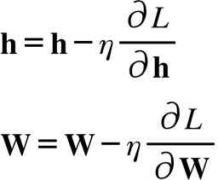

This simple algorithm was simulated for the vocabulary{the cat sat slept} with corresponding training token IDs {1 2 3 1 2 4}, e.g. "the cat sat the cat slept. The embedding is a 2D feature randomly initialized.
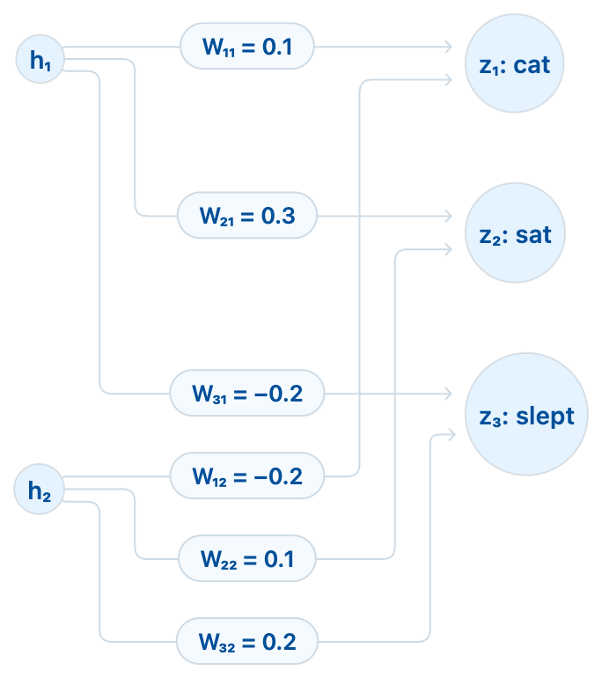

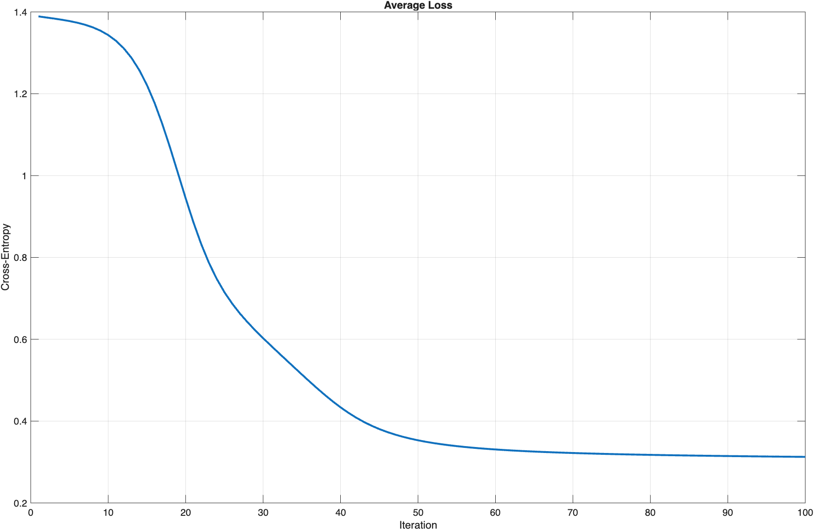

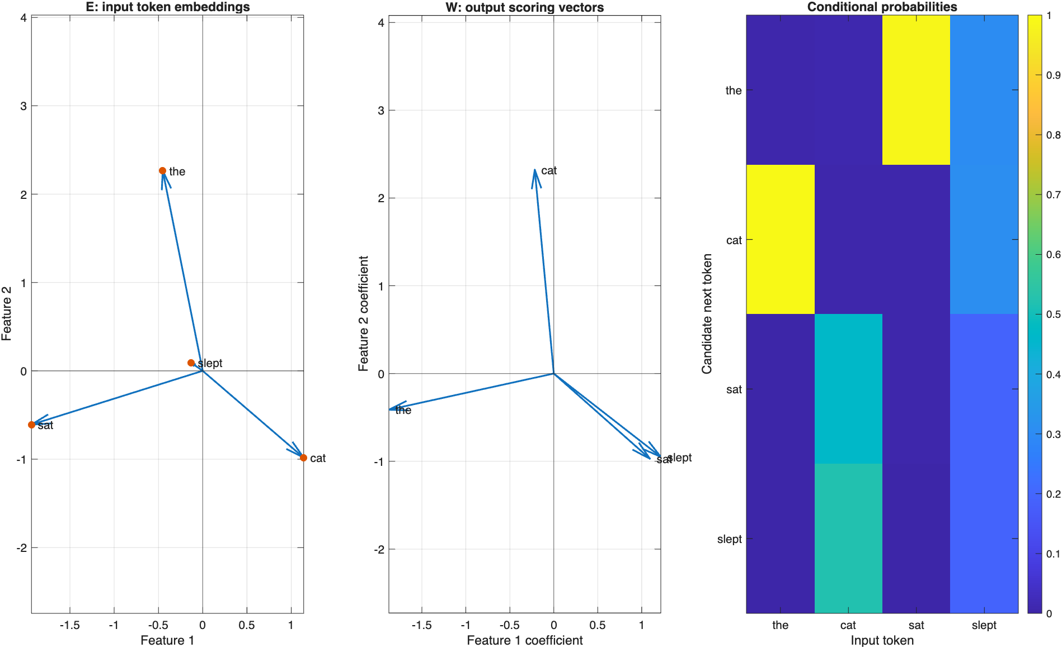
The main difference between this simple example and actual LLMs is in the input output relationship. In real networks the score is a layered nonlinear mapping with a large context,

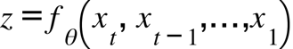

Here theta represents the learned parameters E,W, biases, normalization parameters, etc. This enables predictions with fuller more elaborate contexts similar to real language. For example

the dog eats meat
the cat eats fish

After 'eats' adjacent only context cannot help decide meat or fish. A model using two preceeding tokens could distinguish them.

There are also more network layers, hidden, in a cascaded form such that

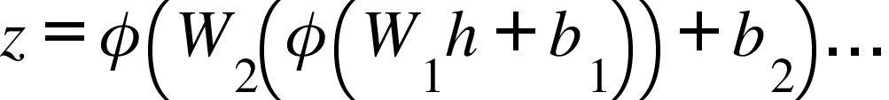

Gradient-Based Learning

Back Propagation

Convolutional Networks

Transformers

Generative Pretrained Transformers

